TEMPLATE SPI5 AUDIT REPORT

General considerations and recommendations for writing the summary report.
Language This report is first and foremost for the FSP management. Therefore it should initially be written in the native language used by the staff of the FSP. After the report has been vetted internally, it can be translated into English, which will allow the results to be shared more easily among other stakeholders, the networks, investors, and other external stakeholders. Cerise+SPTF encourages the auditors to send a copy in both languages.

Organization The summary should be well structured, to facilitate easy and fast reading.

Pictures Blocks of text are impersonal and not very tempting to read. Pictures of clients and the FSP staff give the reader a glimpse of reality.

Length It’s a summary, not a detailed report! Focus on the most important information. The reader wants a quick overview of the FSP’s results.

Audience Remember the different people who will read the summary (investors, microfinance experts, practitioners, networks, TA-providers, general public) and tailor your prose to what they need to know.

Communication strategy of SPI results and summary
- Ask for FSP management to validate the summary.
- Encourage the FSP to disseminate the summary or abstracts of it to:
- Internal stakeholders: board of directors, staff, clients
- External stakeholders: donors, investors, technical assistance providers, partner organizations, parent organization
- Local and regional networks
- Etc.

Social and Environmental Performance of [Name of FSP]
[Country, Month Year]

Introduction
Summarize the organization’s approach and reasons for applying SPI5 in a few sentences.

The social and environmental audit of the financial institution was conducted using SPI5, a comprehensive social audit tool that allows FSPs to evaluate their level of implementation of the Universal Standards for Social and Environmental Performance Management (Universal Standards). SPI5 assesses a FSP’s strengths and weaknesses on both Social and Environmental Performance Management (SEPM) and on Client Protection (CP), with the goal of using this information to help the financial institution improve its management systems and practices over time. SPI5 includes a “core” module that consists of:
- The Universal Standards for Social and Environmental Performance Management - a comprehensive manual of best practices created by and for people in microfinance as a resource to help financial institutions achieve their social goals.
- Client Protection Certification Standards - the minimum standards that clients should expect to receive when doing business with a financial institution.

This report summarizes the findings of the SPI5 audit, conducted by name from DATE to DATE.

[feel free to add pictures of the FSP, clients]

Description of the FSP
Provide a brief description of the financial institution giving details not contained in the Introduction above, including social objectives, areas of operations, methodology and services provided (financial and non-financial). Describe the FSP’s context, history and any particularities. Please mention any key partners, affiliations or parent organization.

Key Social and Environmental data <Month Year>

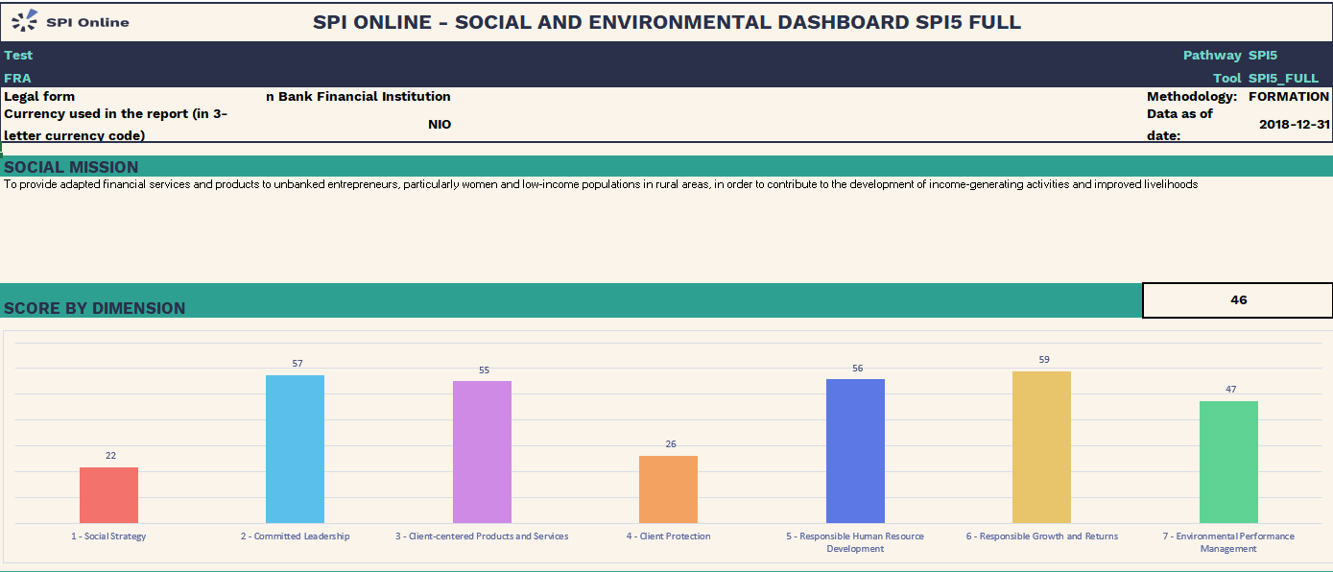
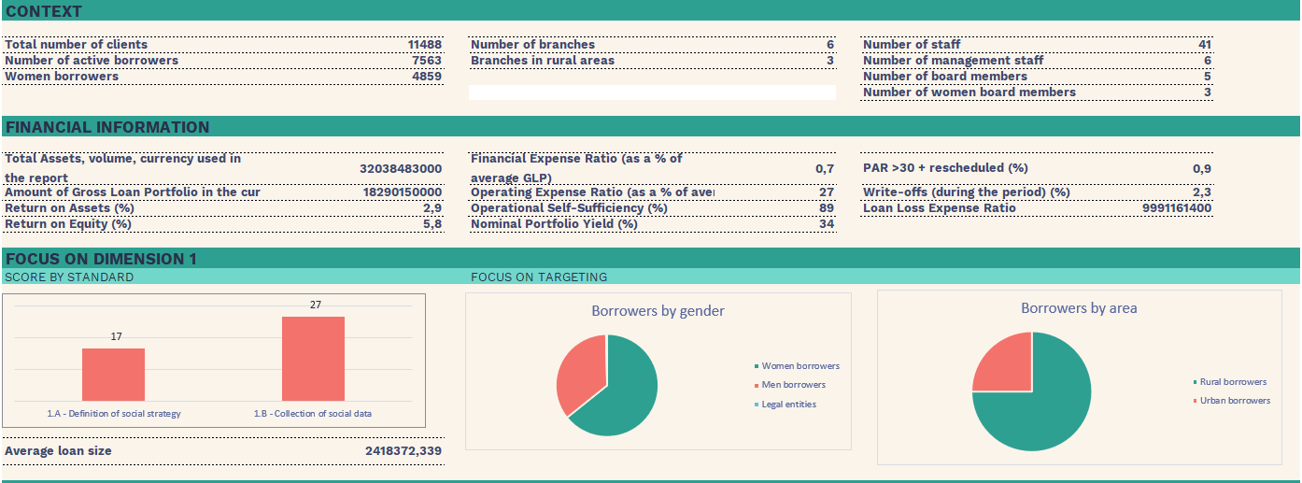
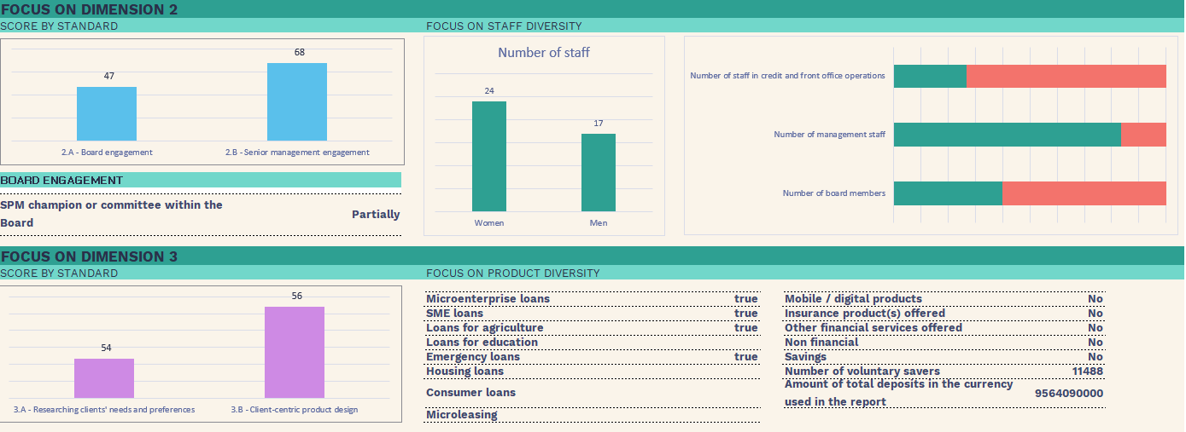
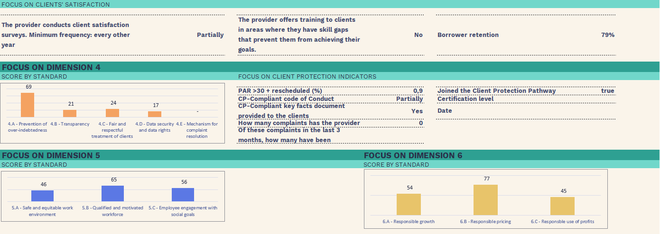
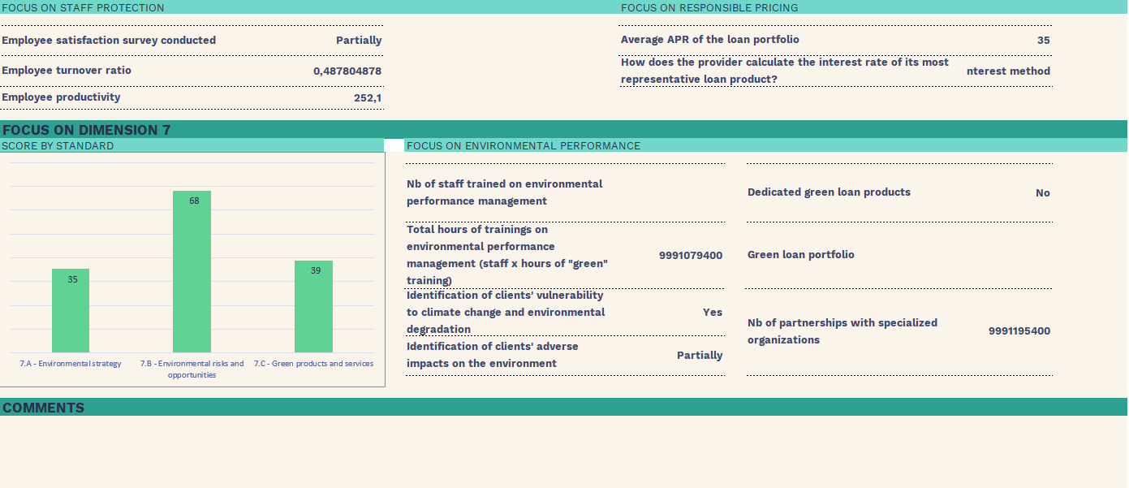
Universal Standards Results by Dimensions

Social Strategy (XX%)

Dimension 1 is about the importance for a financial service provider to develop its social strategy. The first step is about defining social goals, i.e. the specific benefits that its products and services will create for clients. Then the provider must collect data on its progress toward those goals and use those data to guide decisions.

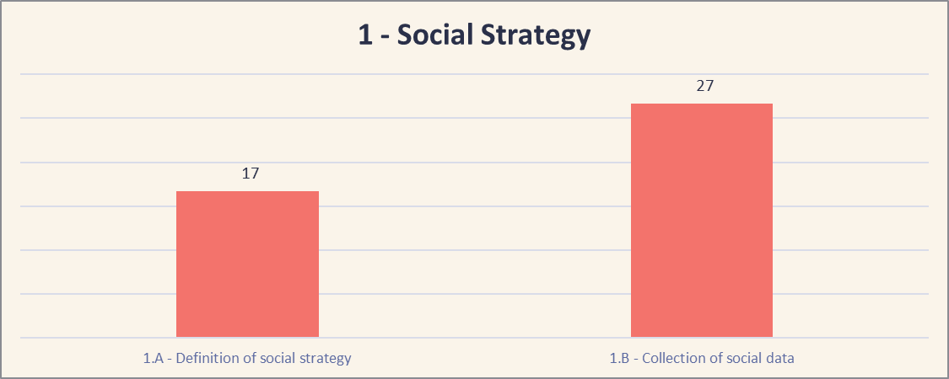
[insert the FSP’s graph results]

Summarize the FSP’s activities and efforts to date in addressing the 2 standards in Dimension 1.
Start with the positive results, i.e., those standards on which the FSP obtained a (very) good score. Mention special efforts or circumstances that explain why the FSP obtained these results and if there are any initiatives pending whose implementation will influence this score in the near future. Conclude with recommendations and areas of improvement i.e. those standards for which the FSP did not obtain a good score. Either address each of the standards in separate paragraphs or summarize the whole dimension in one paragraph.

Committed Leadership (XX%)

Commitment to social performance starts at the top. A social strategy is only strong if the Board and senior management understand and uphold it. In order for social performance to be fully embedded in the organization, the governing bodies and senior leadership must build it into the organization’s plans and accountability structures. The governance and management should be clear, committed and incentivized to achieve the provider’s social objectives.

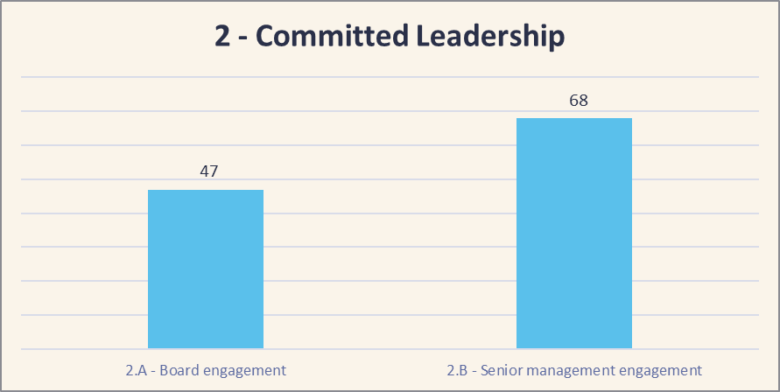
[insert the FSP’s graph results]

Summarize the FSP’s activities and efforts according to the 2 standards.

Client-centered Products and Services (XX%)

Client-centered design means thinking through how financial and non-financial services fit into your target clients’ lives and help them achieve their financial goals and then designing accordingly. In order to do this, you must listen to your clients to understand how the needs and product use of different client groups vary, how client satisfaction and exit varies by client group and the reasons behind these. Products and services should be designed to reduce barriers to financial access as well as helping clients achieve financial goals like coping with risk and emergencies, investing in opportunities, smoothing income or creating a safety net.

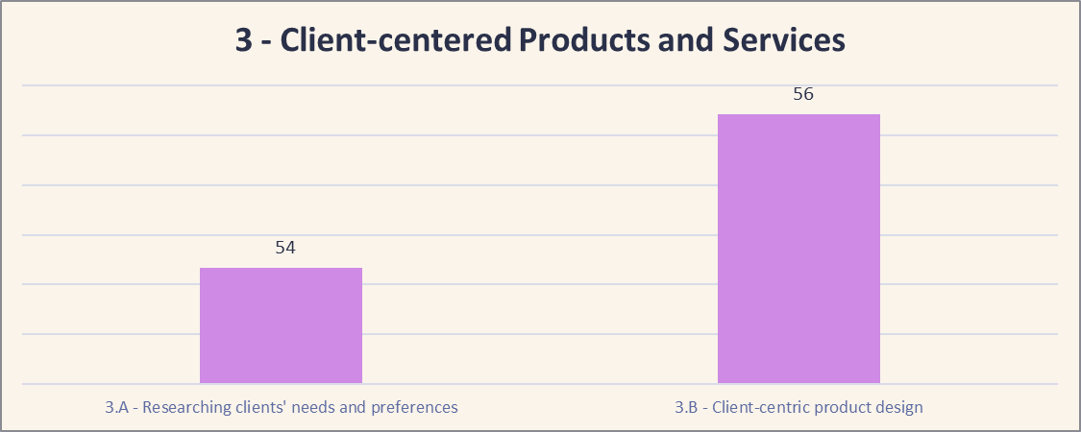
[insert the FSP’s graph results]

Summarize the FSP’s activities and efforts according to the 2 standards.

Client Protection (XX%)

Client protection is the minimum standard for all responsible financial service providers. The standards in this dimension ensure that the financial institution has the practices and systems in place to prevent harm to their clients, while those clients access and utilize their financial and non-financial services. Institutions that seek to create benefits in their clients’ lives must first ensure that they do no harm, and it’s their responsibility to prevent it.

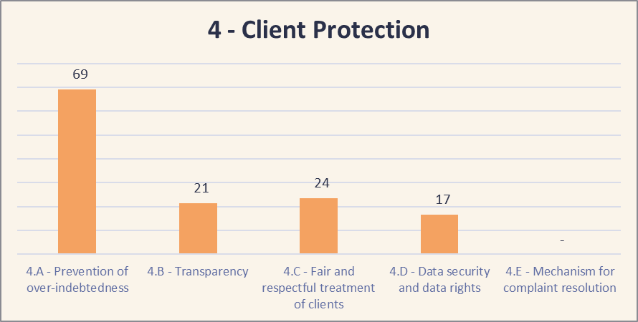
[insert the FSP’s graph results]

<Picture>
You may want to include a quote from one of the customers or other FSP stakeholders (directors, board members, loan officers, etc.) or provide details on an example of good practice.

Summarize the FSP’s activities and efforts according to the 5 standards.

Responsible Human Resource Development (XX%)

Your staff are your greatest asset for achieving your social objectives. Actively value your staff, make sure they're clear on their roles and responsibilities, and listen to their ideas about how to improve your organization - and they will do excellent work for you. Responsible treatment of employees is critical to a successful institution. Employees have rights, and employees that are well-treated are more likely to treat clients responsibly.

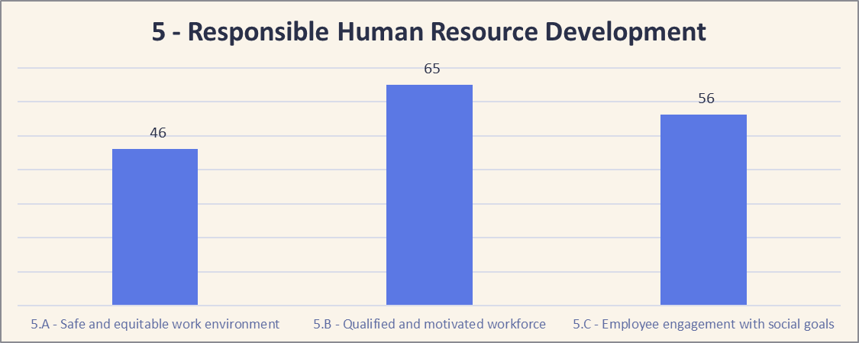
[insert the FSP’s graph results]

Summarize the FSP’s activities and efforts according to the 3 standards.

Responsible Growth and Returns (XX%)

Dimension 6’s standards and guidance start from the premise that, as a social enterprise, an institution’s financial decisions and results should reflect their social goals. As with other social enterprises, striking the right balance is key. As financial institutions grow and take on new funders who may have different priorities or strike a different balance, it is very important for the financial service provider to have institutionalized policies and practices that support its own balance. The 3 primary areas of focus in this dimension are responsibly managing growth, setting prices and using profits to achieve long-term sustainability while achieving social goals.

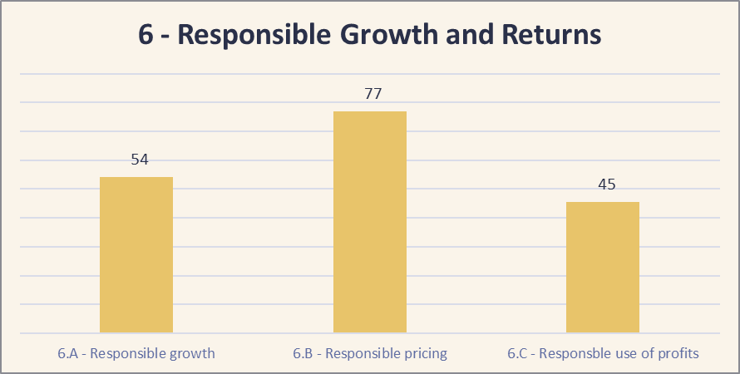
[insert the FSP’s graph results]

Summarize the FSP’s activities and efforts according to the 3 standards.

Environmental Performance Management (XX%)

In a context where climate change and environmental degradation are already affecting every region of our planet, and in particular the most vulnerable populations, it is clear that financial and social sustainability objectives will not be achieved without considering environmental issues. FSPs should seriously engage in improving their environmental performance, avoiding generating negative environmental impacts and contributing to foster climate change adaptation, environmental risk mitigation and regenerative solutions.

Summarize the FSP’s activities and efforts according to the 3 standards.

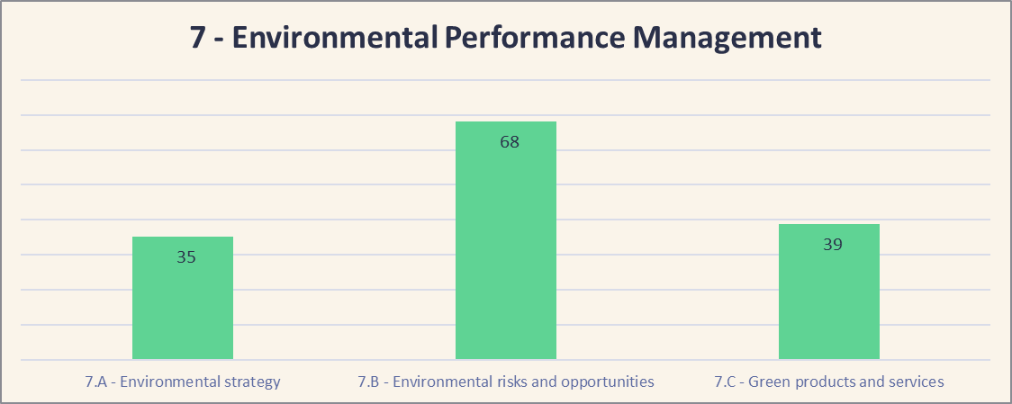
[insert the FSP’s graph results]

Conclusion and Recommendations
Summarize by emphasizing the FSP’s main strengths and identifying 3 to 4 (not more!) key areas of improvement. Propose very concrete steps and actions for the financial institution, addressing the one or two key issues, which could serve as the basis for a SEPM focus in its next business plan. These should be the top priority issues as seen by the auditor, taking into account the results of the SPI5, the institution’s mission and strategic priorities, and their available budget human resources for improvements.

Action Plan Proposal
Using your knowledge of the results of the SPI5 audit, the salient issues in the local context, the institution’s strategic priorities, and the institution’s willingness and ability to allocate budget and HR towards SEPM improvements, the auditor should develop an Action Plan for the FSP that lists all the main areas of improvement. These follow up actions should be prioritized in order of importance/ feasibility beginning with those areas that would be very important to address and not too expensive to fix. This Action Plan should be vetted with the institution’s senior management ideally in order to obtain buy-in for and approval of addressing the highest priority items in the next budgetary cycle.

Optional Reports

SPI5 allows to obtain different reports, so feel free to include below any of those that are relevant for your FSP, such as the FSP scores compared to benchmarks from the Cerise+SPTF database, a detailed dashboard on environmental performance, etc.

Audit results on Client Protection Standards
Paragraph that summarizes overall results around Client Protection. Example: [FSP NAME] meets the standards of care in three of the seven principles, with exceptional practices in fair and respectful treatment of clients, despite a gap in one of the indicators under this principle. Small adjustments are needed to meet the standards in the areas of responsible pricing, fair and respectful treatment of clients, privacy of client data and slightly bigger adjustments will be necessary to meet the standards for transparency, primarily due to the use of flat balance pricing.
Then the auditor can summarize each client protection standard in practice (optional)

And if the FSP is engaged in the CP Pathway, the auditor can explain whether the institution is ready for a certification or not using the graphs from the dashboard CP Full for certification.

